**Report on Day 1 of AICTE-VAANI Sponsored Workshop**

**"Building Inclusive Digital Solutions: AI, Ethics, and Beyond"**

**23rd July 2025** | **Adamas University**

The inaugural day of the three-day AICTE-VAANI sponsored Faculty Development Programme (FDP), titled **“Building Inclusive Digital Solutions: AI, Ethics, and Beyond”**, was held at **Adamas University**, organized by the **Department of Computer Science and Engineering**. The event witnessed an enthusiastic gathering of academicians, researchers, industry experts, and students, united by a common vision to explore the ethical and inclusive dimensions of Artificial Intelligence.

The day commenced with the arrival of dignitaries at **9:00 AM**, followed by the **registration of participants** at the **AU1 Auditorium**.

**Inaugural Ceremony**

The workshop was officially inaugurated at **9:30 AM**, beginning with the **traditional lamp-lighting ceremony**, symbolizing the enlightenment that knowledge brings. The ceremony was graced by:

* **Prof. Dr. Radha Tamal Goswami** – Pro Vice Chancellor
* **Prof. Dr. Sajal Saha** – Associate Dean & Head, CSE Dept and Coordinator
* **Dr. Bodhi Chakraborty** – Co-coordinator
* All **Deans, Associate Deans, Directors,** and **Senior Vice Presidents** from Innovation, Strategy, Corporate Relations, and Career Development Cell
* **HoDs** of various departments

In his **welcome address**, Prof. Dr. Sajal Saha emphasized the importance of the workshop’s theme, stressing the ethical responsibilities associated with AI-driven innovation. The **Pro Vice Chancellor**, Prof. Dr. Radha Tamal Goswami, delivered the **inaugural speech**, highlighting the university's proactive stance on inclusive and responsible AI. Adding to the momentum, **Prof. Saptarshi Chhatterjee**, Director of Innovation and Incubation, shared thoughtful perspectives on fostering innovation within academic ecosystems.

The ceremony concluded with a **group photograph session**, capturing the spirit of collaboration and unity among all participants and dignitaries.

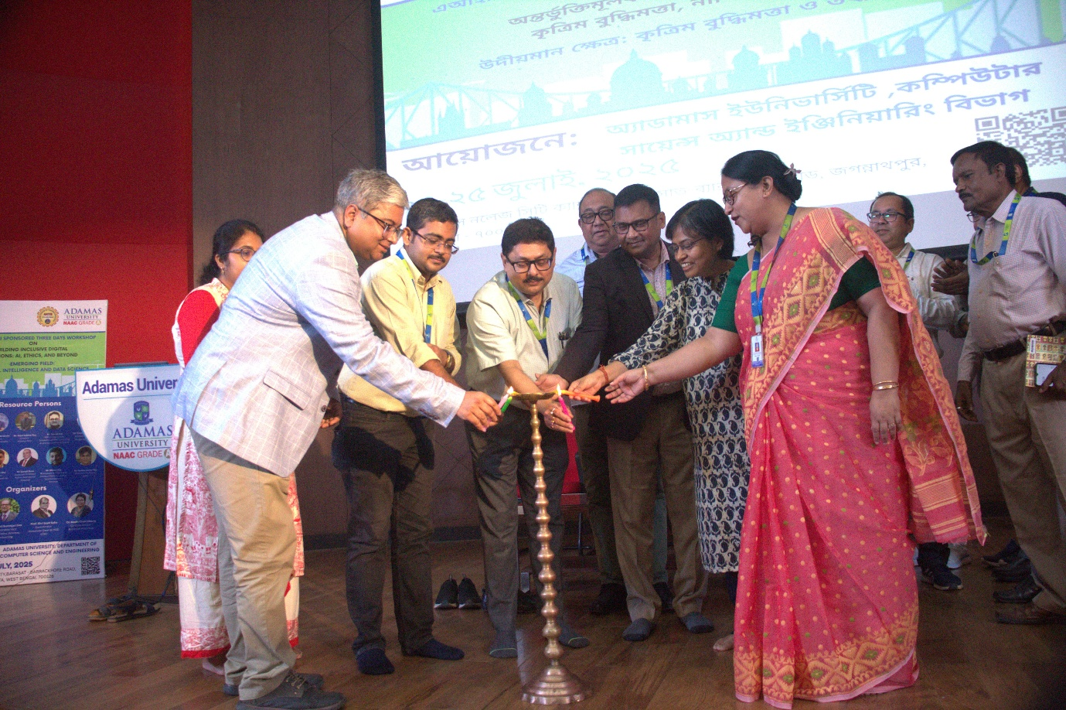

**Expert Sessions (Pre-Lunch)**

The technical sessions for the day began with a lecture by **Prof. Amlan Chakrabarti**, Calcutta University, who delivered a compelling talk on **emerging trends and challenges in AI**. His insights on ethical concerns and the societal impact of AI sparked active engagement from the audience.

This was followed by visionary remarks from the **Hon’ble Vice Chancellor, Prof. Suranjan Das**, who emphasized AI’s role in shaping equitable digital futures. **Prof. Dr. Radha Tamal Goswami**, in his expert address, contextualized **“AI for Bharat”**, aligning AI development with grassroots empowerment and indigenous innovation.

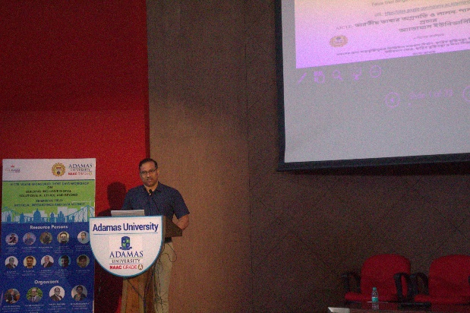 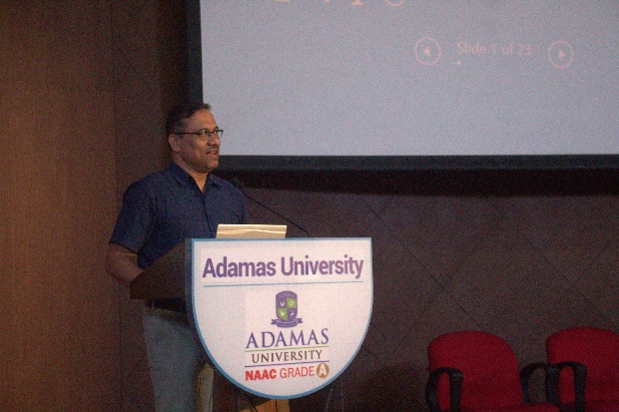

**Lunch Break (1:15 PM – 2:30 PM)**

Lunch was arranged at the university **Food Court .** Participants enjoyed a hearty meal and connected with peers from diverse disciplines including **MBA, MCA, Pharmacy, and Humanities**.

**Expert Sessions (Post-Lunch)**

The afternoon resumed at the **AU6 2102 Lab** with a deep dive session by **Prof. Dr. Sajal Saha**, where practical applications and real-world AI use cases were discussed. His talk offered clarity on transitioning academic AI concepts into viable technological solutions.

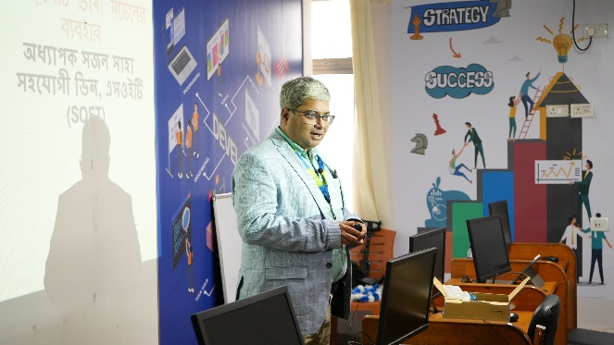 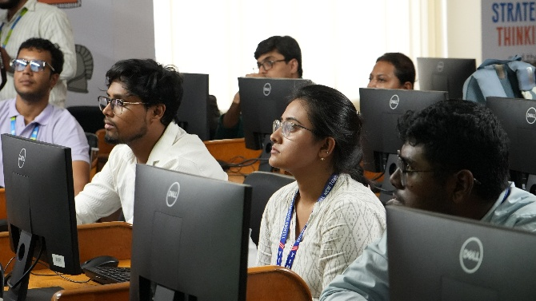

Following this, **Prof. Dr. Nilanjan Dey** delivered a powerful session on **AI-driven assessment systems**, bringing attention to the role of AI in revolutionizing education through automation and personalization.

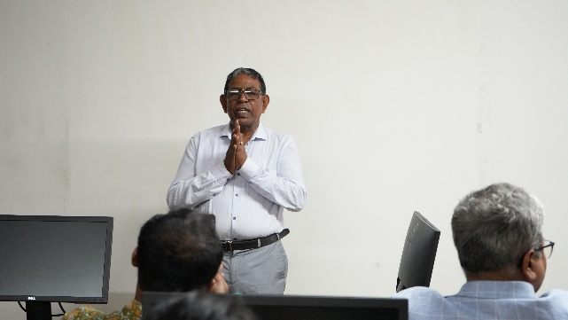 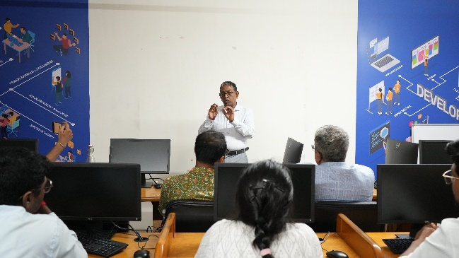

* Total Participants: **84+** from various departments including **Engineering, Management, Pharmacy, and Literature**

**Report on Day 2 of AICTE-VAANI Sponsored Workshop**

**"Building Inclusive Digital Solutions: AI, Ethics, and Beyond"**

🗓 **24th July 2025** | 📍**Adamas University**

The second day of the AICTE-VAANI sponsored Faculty Development Programme continued the momentum established on Day 1, bringing together participants from varied academic backgrounds for a series of technical sessions and discussions centered around ethical, inclusive AI applications. The day's events were held primarily in the **AU6 AIT Video Conferencing Room** and focused on hands-on experiences, emerging technologies, and practical implementations.

The collaborative tone and high energy of the first day carried forward, with participants eager to delve deeper into advanced concepts and applications of Artificial Intelligence.

**Morning Session (10:00 AM – 11:15 AM)**

**Lab Session with Practical Exposure**

The day began with an interactive **Lab Session** conducted by **Mr. Prabhat Das**. This session introduced participants to real-world tools and platforms used in ethical AI model development.

* Participants explored **AI modeling**, **bias mitigation techniques**, and **data ethics practices**
* Faculty and students engaged in hands-on experimentation with curated datasets

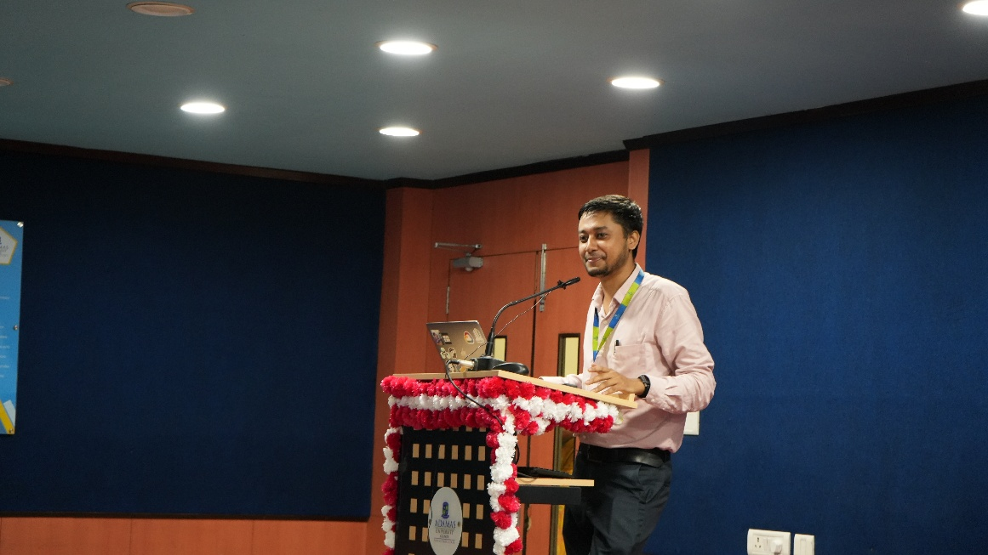

**Tea Break (11:15 AM – 11:30 AM)**

The brief refreshment break allowed participants to relax and discuss their learnings informally.

**Expert Talk 1 (11:30 AM – 1:00 PM)**

**Speaker: Mr. Niladri Roy**

Mr. Roy delivered an insightful lecture on **AI deployment in corporate and industrial settings**, emphasizing:

* The importance of **contextual data analysis**
* Addressing **algorithmic bias** and ensuring **transparency** in decision-making tools
* Building **inclusive AI frameworks** aligned with India’s diverse digital ecosystem

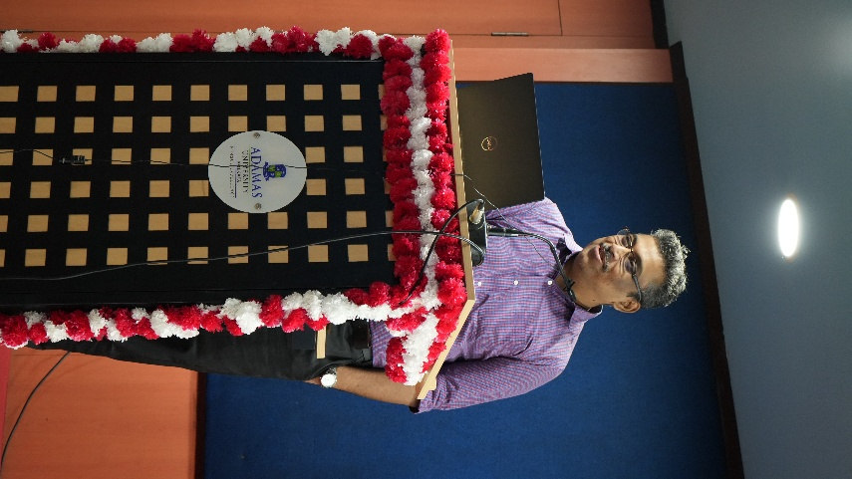 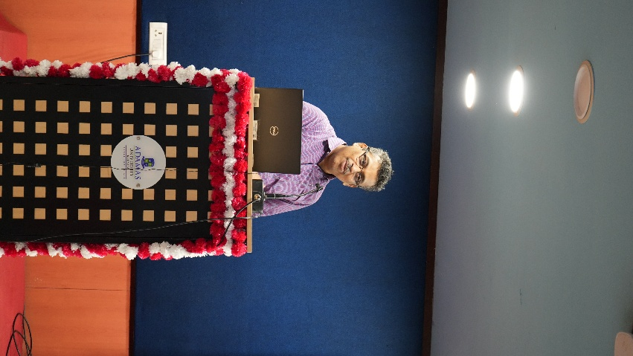

**Lunch Break (1:00 PM – 2:30 PM)**

Lunch was arranged at the **university Food Court**, allowing participants to refuel while networking across disciplines. Special attention was given to ensure a smooth and timely experience.

**Expert Talk 2 (2:30 PM – 3:45 PM)**

**Speaker: Dr. Saptarsi Goswami**

Dr. Goswami’s session explored the intersection of **AI and social good**, with a focus on:

* Case studies from healthcare and public infrastructure
* Ethical frameworks to prevent misuse of AI
* Strategies to build community-centered AI systems

**Tea Break (3:45 PM – 4:00 PM)**

The tea session again served as a valuable time for peer interaction. Conversations often revolved around practical challenges in applying the day’s learning to academic and industry environments.

**Expert Talk 3 (4:00 PM – 5:15 PM)**

**Speaker: Dr. Surojit Bose**

Dr. Bose’s dynamic talk wrapped up the day, delving into **AI and the future of digital learning**. Key themes included:

* Personalized learning paths using AI-based recommender systems
* Integrating AI into traditional classrooms without disrupting pedagogy
* Ethical dilemmas in data collection from learners

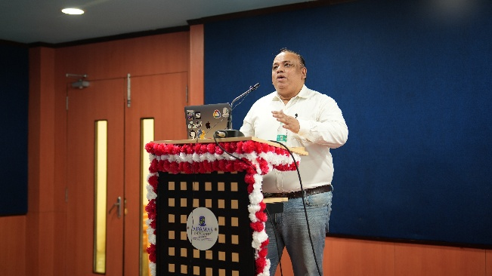 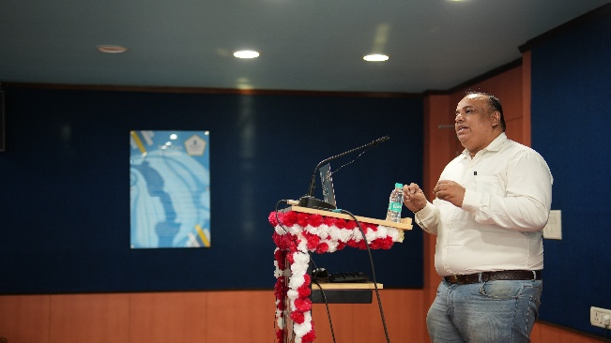

**Day 2 Summary & Reflections**

* Focus: **Practical AI Applications**, **Social Impact**, **Cross-domain Use Cases**
* Format: Lab session + 3 Expert Talks

The second day offered a balanced blend of technical depth and social relevance, reinforcing the workshop’s core theme — building **inclusive**, **ethically-grounded**, and **applicability-driven** digital solutions. Interdisciplinary dialogue was strong, with participants sharing sector-specific challenges and ideas.

**Report on Day 3 of AICTE-VAANI Sponsored Workshop**

**"Building Inclusive Digital Solutions: AI, Ethics, and Beyond"**

🗓 **25th July 2025** | 📍**Adamas University**

The concluding day of the AICTE-VAANI sponsored Faculty Development Programme focused on consolidating the learnings of the previous days through engaging talks, interactive lab sessions, and participant activities. The sessions, held at the **AU6 2102 Lab**, emphasized applied knowledge, feedback collection, and peer reflection—bringing the workshop to a thoughtful and energetic close.

With attendance still strong, participants were eager to engage, collaborate, and gain final insights into ethical AI practices and inclusive digital transformation.

**Morning Activity (10:00 AM – 10:45 AM)**

**Questionnaire / Quiz Session**

Day 3 kicked off with an **interactive quiz and reflection activity**, designed to revisit key concepts discussed throughout the workshop.

* Conducted by **Dr. Bodhi Chakraborty**
* Focused on AI ethics, inclusion strategies, and real-world applications

**Tea Break (10:45 AM – 11:05 AM)**

The short break allowed participants to unwind, network, and discuss quiz responses informally.

**Expert Talk 1 (11:00 AM – 12:30 PM)**

**Speaker: Mr. Souvik Das**

Mr. Das delivered a captivating session that explored:

* **Human-centered AI design**, with a focus on inclusive accessibility
* The **UX perspective** in AI-based applications
* Building intuitive and ethical AI tools for educational and societal use

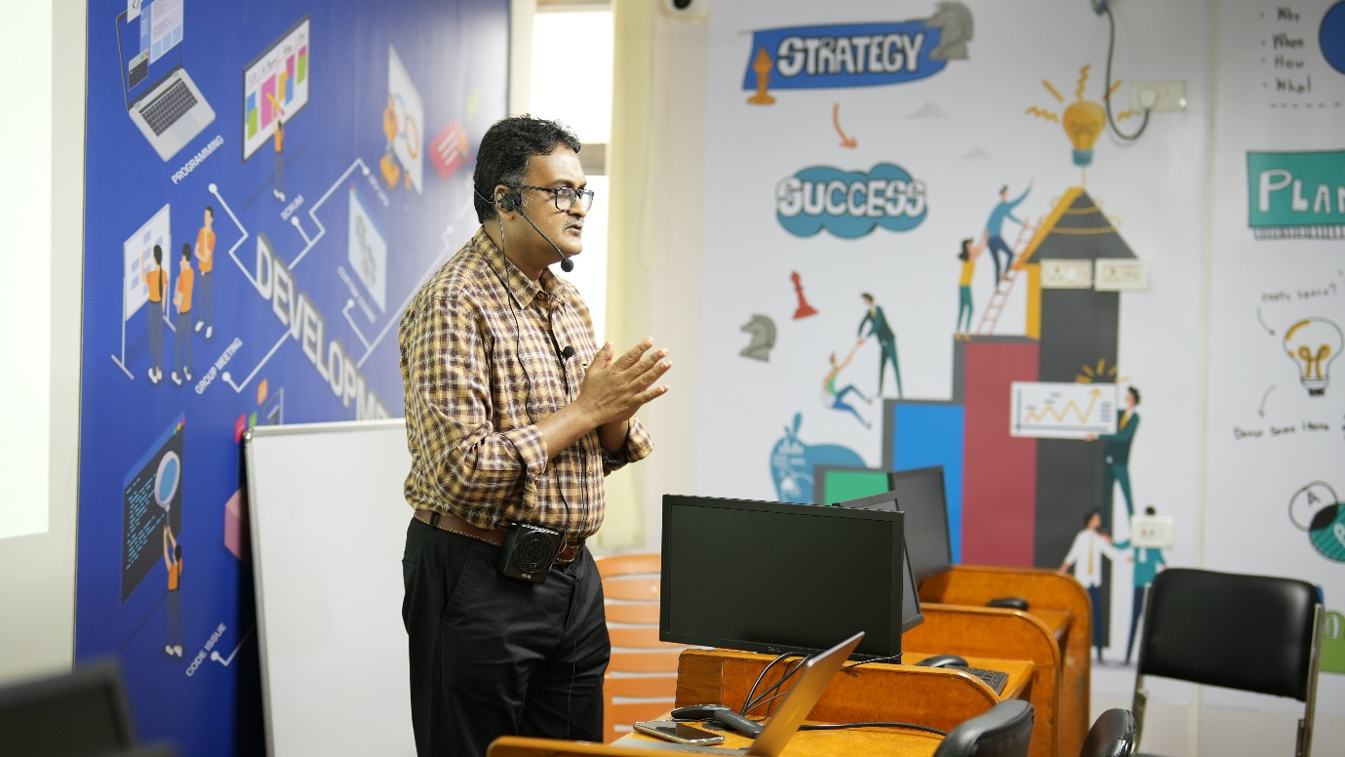

**Lunch Break (12:30 PM – 2:00 PM)**

The lunch break at the **Food Court** was seamless and well-coordinated. It also served as an informal feedback exchange session among participants.

**Expert Talk 2 (2:00 PM – 3:15 PM)**

**Speaker: Dr. Swalpa Kumar Roy**

Dr. Roy spoke extensively on **AI governance**, touching on:

* Policy development for AI ethics
* The role of institutions in creating accountability
* The need for inclusive AI standards across industries

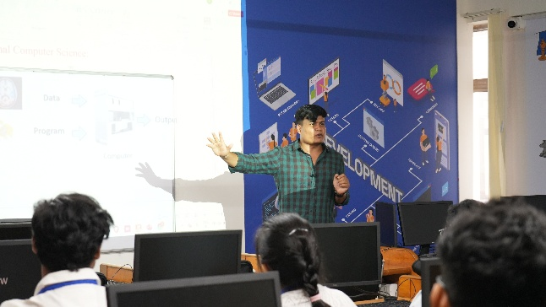 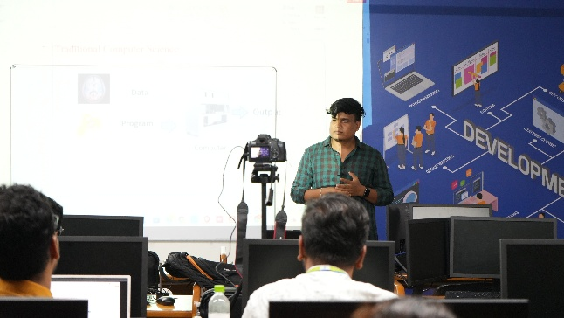

**Lab Session (3:15 PM – 4:30 PM)**

The final technical session was a **hands-on lab activity**, designed to apply the workshop’s lessons in a simulated development environment.

* Participants built simple models aligned with inclusive design principles
* Data handling practices, fairness metrics, and ethical filtering were integrated into the tasks
* Peer reviews were encouraged to foster open discussion

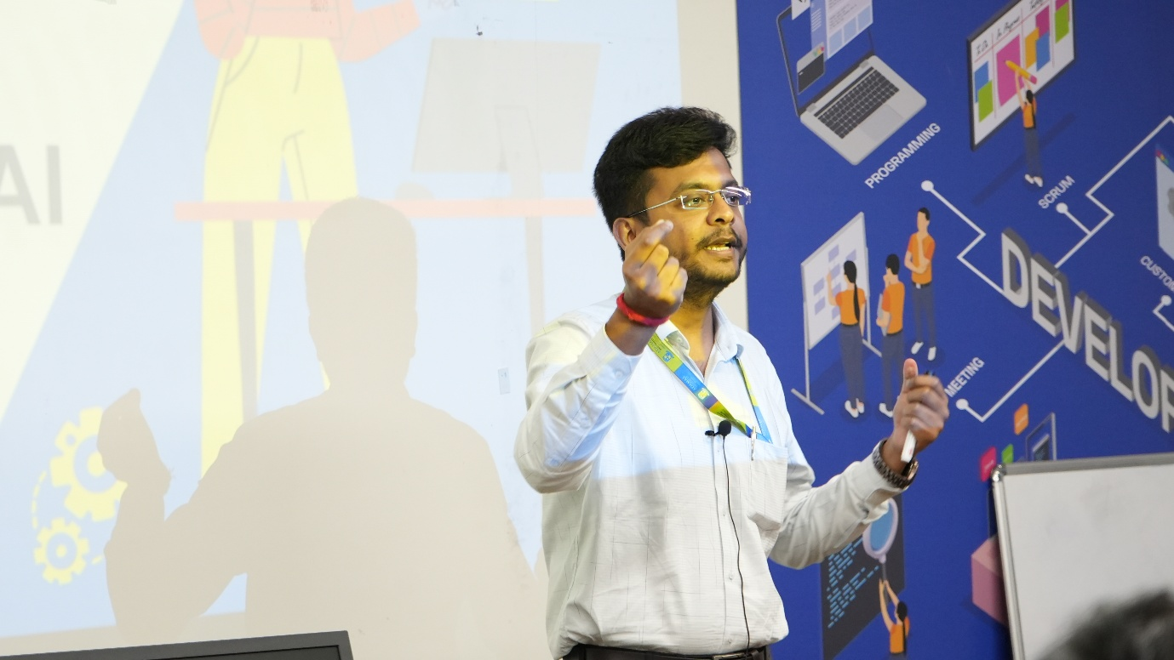

**Valedictory & Feedback Session (4:30 PM – 4:45 PM)**

Led by **Dr. Bodhi Chakraborty**, the **valedictory session** brought the workshop to a heartfelt conclusion.

* Participant feedback was collected
* Certificates of participation were announced
* Reflections on the workshop’s impact were shared by faculty and attendees alike

**Closing Tea Break (4:45 PM – 5:00 PM)**

The final tea session served as a moment of celebration and informal goodbye among participants, speakers, and coordinators.

**Workshop Closure Note**

The three-day workshop concluded on a high note, equipping participants not only with technical knowledge of AI but also with the **ethical grounding, collaborative mindset, and inclusivity principles** required in the 21st-century tech ecosystem. Adamas University, in collaboration with AICTE-VAANI, successfully created a vibrant platform for knowledge exchange and societal impact.